**Kick Starter Campaigns**

1. **What are three conclusions we can make about Kickstarter campaigns given the provided data?**

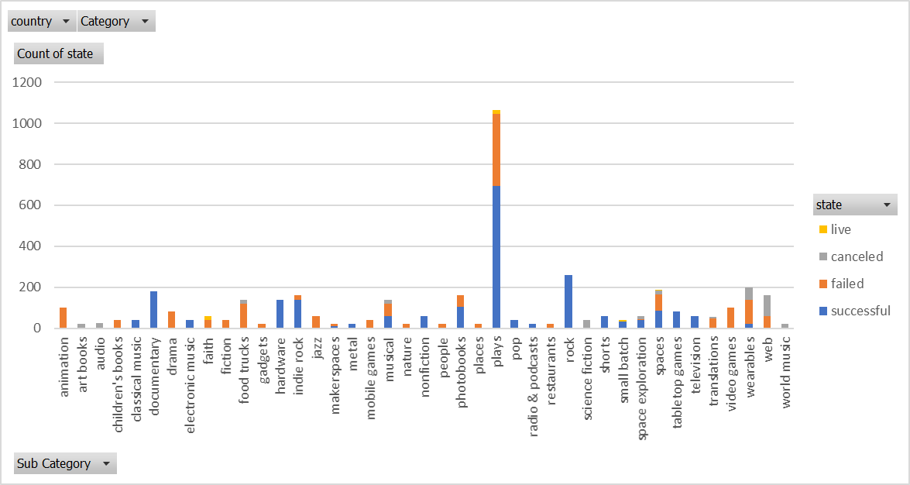

* Classical music, documentary, electronic music, hardware, metal, nonfiction, pop, radio & podcasts, shorts, tabletop games, and television are categories that have had only “successes”. These are good investments. Animation, children’s books, drama, fiction, restaurants and video games have only “failures”. These are poor investments. (It may be advantages to understand why some are successful and why some are not to aid in future planning).



Technology is a risky business based on the number of successes, failures and canceled campaigns. Out of 600 instances, 209 (34.9%) have been successful, 213 (35.5%) have failed and 178 (29.6) have been canceled. This means you *almost* have an equal chance to succeed, fail or be canceled.



Historically, it appears that May is a good month for the campaign to be created since it has the highest “successful” count of 238. Unfortunately, based on the data, October is not a good month for the campaign to be created since it has the most failures with a “failed” count of 150.

1. **What are some of the limitations of this dataset?**

Some Limitations are:

* This data for the funds does not take into account the different values of the currency for the pledge, goal and average donation. All of the donations are not US dollars.
* We do not know how long each backer has to make the pledge. We have only the deadline but not the actual date of the commitment for the pledge.
* We do not know how long it takes for the campaign to be canceled.

1. **What are some other possible tables/graphs that we could create?**

Some other possible tables/graphs are:

* Show a pie chart that displays the percent of the subcategory for each category. As we look at successes and failures it would be nice to see if you eliminate a specific subcategory, would it improve the success of the category.
* Show a chart of which country is successful by backers. You can easily see which country is getting more support and try to understand why.
* Graph which projects do not get any pledges to understand why there is no interest in these projects. Also compare this to the staff picks. Next, determine if the staff members are marketing to only projects that are of interest to them.